|  |  |
| --- | --- |
| **YEAR 8** | **Forms of Energy** |

|  |  |
| --- | --- |
| **Learning Intentions** | **Success Criteria** |
| Understand that energy appears in different forms. | * Recognising that kinetic energy is the energy possessed by moving bodies * Recognising that potential energy is stored energy, such as gravitational, chemical and elastic energy * Investigating different forms of energy in terms of the effects they cause, such as gravitational potential causing objects to fall and heat energy transferred between materials that have a different temperature |



**Image:** [**https://encrypted-tbn0.gstatic.com/images?q=tbn%3AANd9GcT1s8C4VmWkFuzS-deLduRcIlOR4LryR11awjEOIeLFmuDbsZH9&usqp=CAU**](https://encrypted-tbn0.gstatic.com/images?q=tbn%3AANd9GcT1s8C4VmWkFuzS-deLduRcIlOR4LryR11awjEOIeLFmuDbsZH9&usqp=CAU)

**READ:** *What is Work?*

**Work** is the name given when energy is used. Whenever an object is shifted or forced to change shape, then work has been done.  
**READ:** *What is Energy?*

**Energy** is the ability to do work. It is needed to make a change happen. It cannot be seen but you can observe changes as a result of energy acting.Energy is needed to move or heat something, to make noise or to change an objects shape.

Most energy on the Earth originates from the **Sun**. The unit used to measure energy is the **joule (J). Energy can exist in many different forms.**

Some of the different **forms of energy** include:

* Heat energy
* Light energy
* Sound energy
* Chemical energy

**WATCH:** *What is Energy?*

|  |  |
| --- | --- |
| File:Logo of YouTube (2015-2017).svg - Wikipedia | Watch this YouTube video:  <https://www.youtube.com/watch?v=CW0_S5YpYVo> |

**ACTIVITY 1:** *Types of Energy*

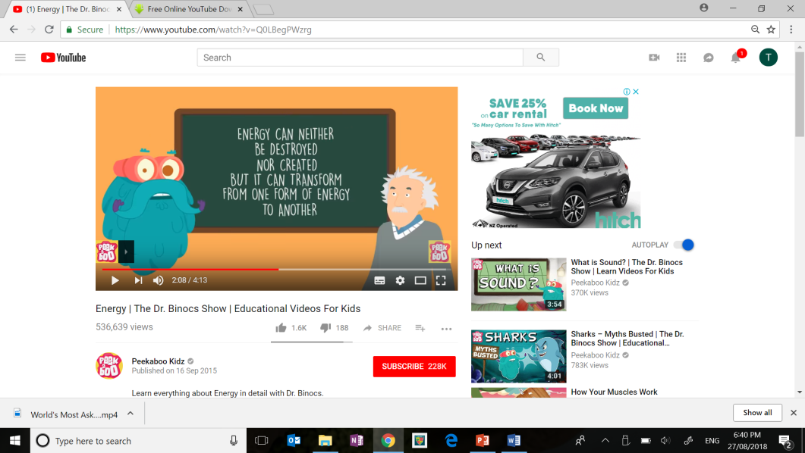**YOUR TASK:** Learn everything you need to know about energy in detail with Dr. Binocs. As you watch the video about energy, create a list of different types of energy. Once you have your list, draw pictures to help you remember the different forms of energy.

|  |  |
| --- | --- |
| File:Logo of YouTube (2015-2017).svg - Wikipedia | Watch this YouTube video:  <https://www.youtube.com/watch?v=CW0_S5YpYVo> |

|  |  |  |
| --- | --- | --- |
| Types of Energy   * ____________________ * ____________________ * ____________________ * ____________________ * ____________________ * ____________________ * ____________________ * ____________________ * ____________________ |  | Pictures |

**READ:** *Types of Energy*

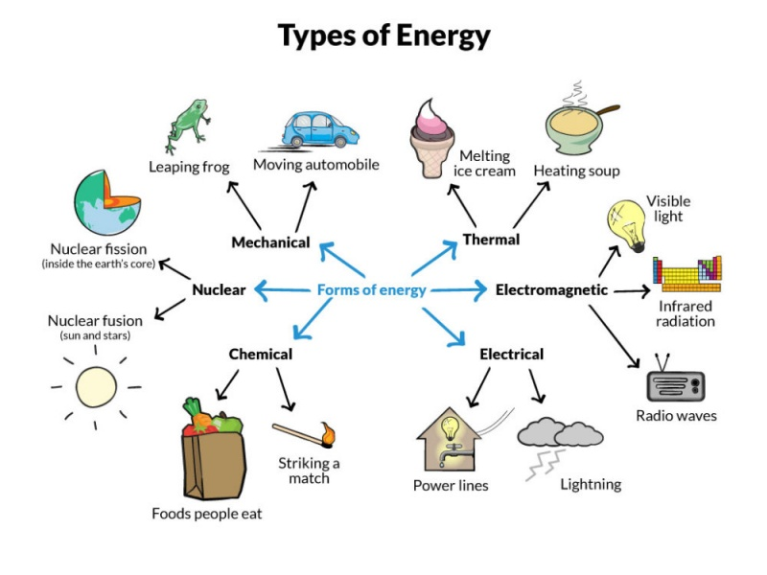

**SOURCE:** <https://www.solarschools.net/knowledge-bank/energy/types>

All types of energy can be categorized into two groups: ***potential & kinetic.***

**Mechanical energy** is a mix of kinetic (energy in motion) and potential energy (energy that is stored).

The sum of an object’s kinetic and potential energy equals the object’s total mechanical energy.

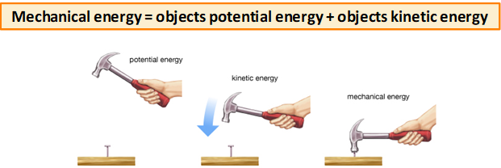 **SOURCE:** Encyclopedia Britannica

**ACTIVITY 2:** *Investigating Forms of Energy*

**PART 1:** Complete the research table about the different forms of energy.   
  
**PART 2:** Use your research to create an information document describing each form of energy.

Choose to create one of the following options:

* Poster (digital or paper) – *space provided in this workbook*
* Booklet
* PowerPoint
* Website

**PART 1: Research**

|  |  |  |  |
| --- | --- | --- | --- |
| **Forms of energy** | **Definition** | **Is it stored energy?** (Potential Energy) | **Examples** |
| **Gravitational** |  |  |  |
| **Chemical** |  |  |  |
| **Elastic** |  |  |  |
| **Nuclear** |  |  |  |
| **Thermal** |  |  |  |
| **Light** |  |  |  |
| **Sound** |  |  |  |
| **Electrical** |  |  |  |

**PART 2: Presenting your research**

**YOU TASK:** Use the space below if you would like to present your research as a poster.

|  |
| --- |
| Forms of Energy |

**END OF WEEK TEST:** *Forms of Energy*  
 **Question 1**Compare the terms *energy* and *work*.

|  |
| --- |
| Energy is |
| Work is |

**Question 2**Match the energy type to its examples.

|  |  |  |
| --- | --- | --- |
| **Energy Type** |  | **Examples** |
| Nuclear |  | *Light bulb, fire, sun* |
| Electrical |  | *Anything that uses electricity* |
| Gravitational |  | *Bungee rope, sling shot, stretched rubber band* |
| Sound |  | *Hot water, radiator, stove* |
| Elastic |  | *Atomic/nuclear bombs, nuclear power stations,*  *the sun and stars* |
| Light |  | *Food, fuel, batteries, burning things* |
| Thermal (Heat) |  | *An object at height (i.e. a book on a bookshelf)* |
| Chemical |  | *Music, radio, TV, talking* |

**Question 3**

Identify the energy type(s) in each of the following…

***HINT:*** *There may be more than one.*

|  |  |  |
| --- | --- | --- |
| **(a)** | Food |  |
| **(b)** | Fire |  |
| **(c)** | TV |  |
| **(d)** | Sun |  |
| **(e)** | Car |  |
| **(f)** | Wind-up toy |  |

**Question 4**Draw a diagram that describe the relationship between potential, mechanical and kinetic energy. Include labels and descriptions with your diagram.

|  |
| --- |
|  |

Rate your understanding of forms of energy:  
 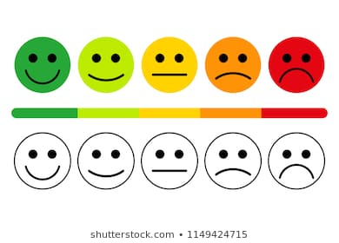

**[WARNING]**

Some of this material may have been copied [and communicated to you] in accordance with the statutory licence in section 113P of the Copyright Act. Any further reproduction or communication of this material by you may be the subject of copyright protection under the Act. Do not remove this notice.

These resources have been made available by the Department of Education Western Australia in response to COVID-19 on 22/04/2020 for your educational purposes. Do not distribute these resources for any other purpose.